Objective
Final integration of the project’s codebase and submission of the milestone for review by the product owner.

Due Date/Time
Must be integrated and added to the remote repository by 9am on the day of the milestone.

Materials
Git (https://git-scm.com/downloads)
TortoiseGit (https://tortoisegit.org/download/)
Unity (https://unity3d.com/)
A Unity Project
Access to a Git server
Installer
Bug Tracker (Excel Document)

Procedure
Step One
Complete a code freeze of the master branch

With enough time to allow for testing and submission of the milestone (preferable the night before) have each team member integrate any work not yet integrated to the master branch. Be careful to ensure you don’t lose any work in this process (Commit, pull, test, commit, push).

Step Two
Test the build in unity

Have each team member use the product in unity to ensure there was no loss or work, things left out of the build, or major bugs introduced during the integration

Step Three
Export a copy of the build

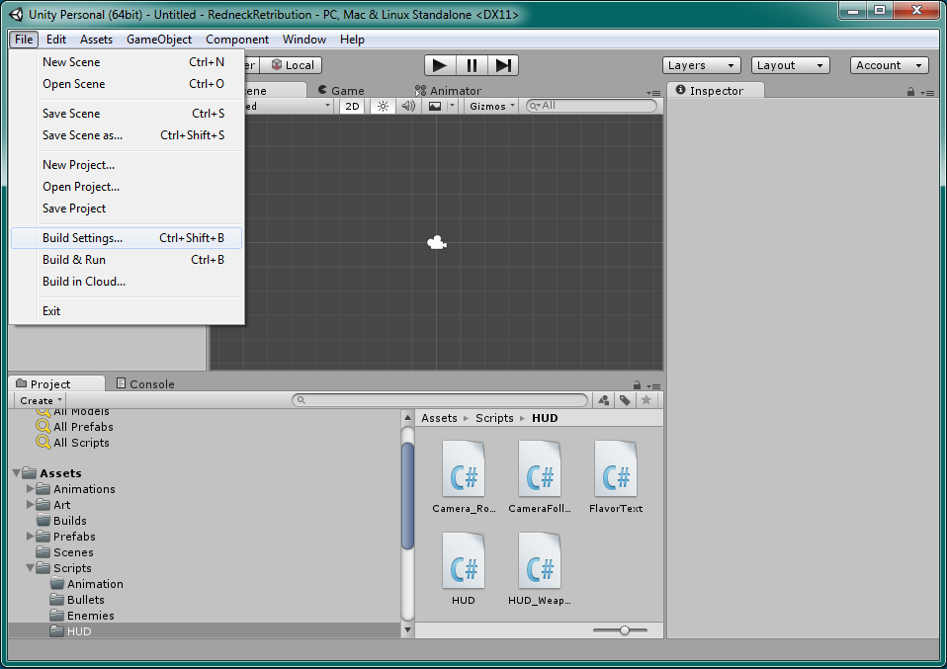

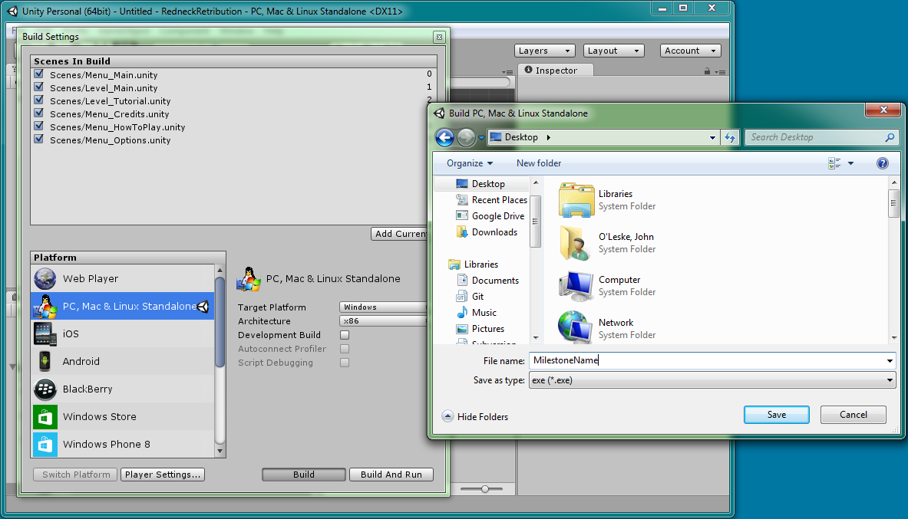

Step Four
Test the build from the exe

Have the team member exporting the build test it to ensure there was no loss or work, things left out of the build, or major bugs introduced during the export. There are bugs that can show up in the exported build that do not happen inside of the unity environment.

Step Five
Create an installer for the final version of the build

Step Six
Clean up the Milestone Build folder

Using Git delete the content in the Milestone Build folder of the repo if there is a build in there from a previous milestones

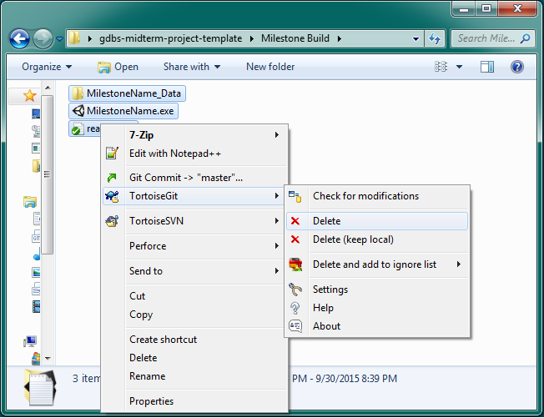

Commit these changes to the repo

Step Seven
Copy the installer into the milestone build folder.

Step Eight
Download a copy of the bug tracker from Google drive
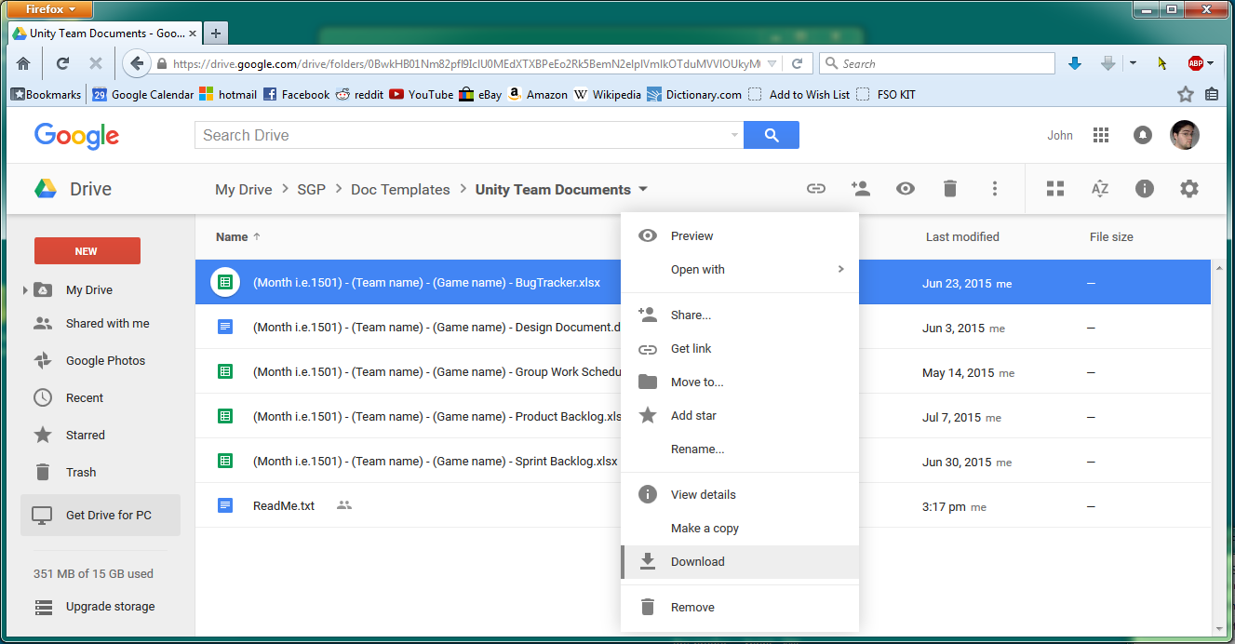

Step Nine
Add the bug tracker to the “Docs” folder of the repo, commit the addition, and push the changes to the remote repo
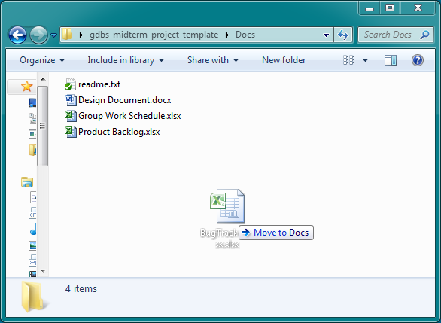

Step Ten
Test the installer and build on an additional computer

Have each team member pull from the server and receive the milestone build. Test the build to ensure there was no loss or work, things left out of the build, or major bugs introduced during the push and commit to the repo.

Step Eleven
After all testing has been completed and the build is ensured to be the one intended for submission add a Tag to the version in Git, labeling it for the milestone. Commit and push the final version to the remote repo with the “Include Tags” check box checked

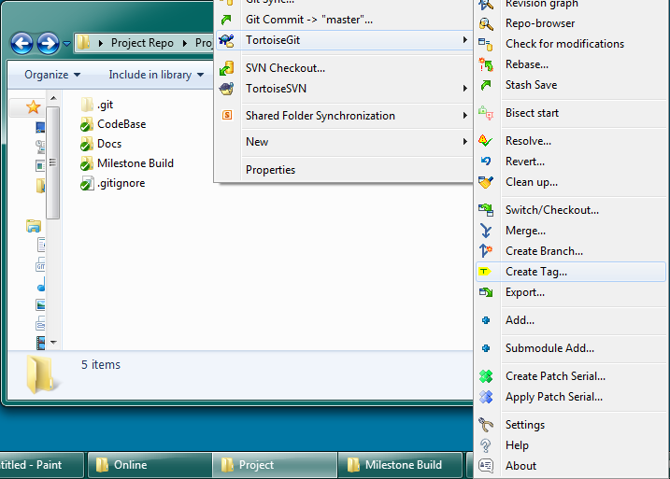

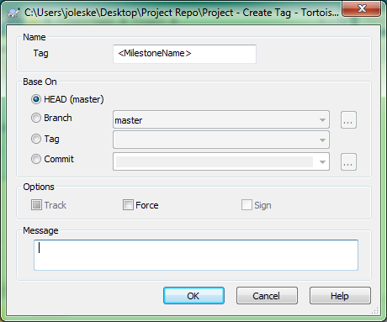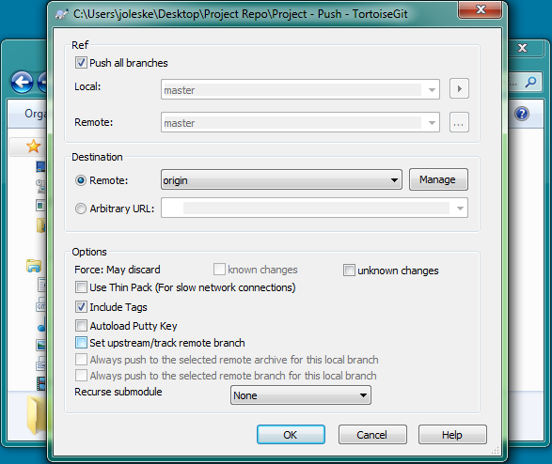

Work submitted:
The milestone build will be pulled from the Milestone Build folder on the remote repo the morning of the milestone.

